Contents
What is JSP and how it is different with Servlet? 3
Life Cycle of JSP 3
Initializing Your JSP 4
Attributes / Scope in JSP 5
Directory Structure of Web Application 5
JSP Elements Types 5
Scriplet 5
Expression 6
Directive 7
Jsp / Servlet Code Mapping 8
Implicit Object of Jsp 9
Using pageContext 10
Exception Handling in JSP 10
Overriding jspInit() 11
A Comment… 12
Types of Directives 13
Few attributes of Page Directive 13
How to Invalidate Scriplet 14
How to enable / disable Expression Language (EL) 14
Standard Action elements 15
Jsp:useBean and jsp:getProperty 15
Jsp:setProperty 16
<jsp:include> Standard Action 16
<jsp:forward> Standard Action 18
The Include directive 19
Custom Tag 20
Why do we need Custom tag in JSP? 22
Steps to create a custom tag 23
JSP Custom Tag with attribute with database 24
JSP Custom Tag with Body content & attribute 24
When do we need to create JAR file for tlds? 24
Basic of Expression Language (EL) 25
Few JSTL Syntax 27
<c:out> 27
<c:forEach> 28
<c:if> 28
Configuring Error page in DD 29
MVC Architecture 29
Registration Form in JSP 29
Login and Logout Example 30
Uploading file to the server 30
Downloading file from the server 30
Auto Page Refresh 30

What is JSP and how it is different with Servlet?
JavaServer Pages (JSP) is a server-side programming technology that enables the creation of dynamic web pages and applications. This is accomplished by embedding Java code into HTML, XML, DHTML, or other document types. When a client such as a web browser makes a request to the Java application container, which is typically a web server, the static page is converted behind the scenes, and displayed as dynamic content to the viewer. It has been speculated that JSP was released to compete with PHP, a commonly used open-source programming language.
Differences are:
- Both are Server-side technologies. HTML code can be embedded into Servlet but in JSP Java code is embedded into HTML. So, JSP is helping out developer to do presentation logic.
- Servlet need to re-compile after every change but in JSP Container will be taken care these things automatically.
- JSP are internally converted into Servlet but one can do only HTTP based programming with JSP. In Servlet, programmer can have flexibility to do either HTTP based or any other protocol due to GenericServlet.
- JSP can easy to learn and program.
- JSP is mainly used for defining Presentation Logic whereas Servlet is mostly used to define Business Logic (As a Front Controller / Controller inside MVC architecture)

Life Cycle of JSP
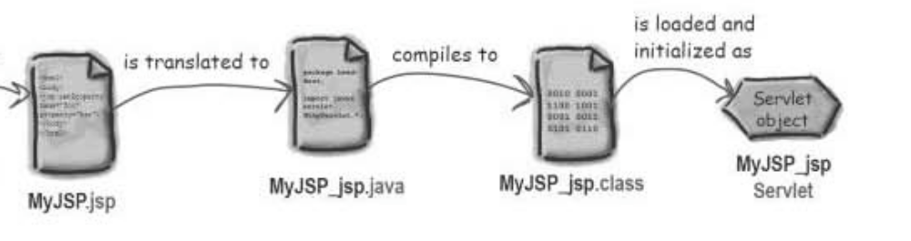
Translation and Compilation
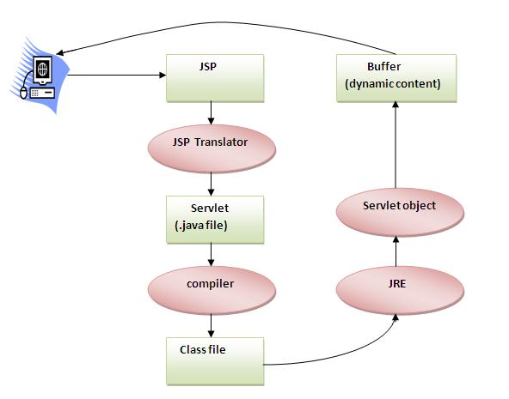
jspInit() -> You can Override this
_jspService() -> You can’t Override this
jspDestroy() -> You can Override this
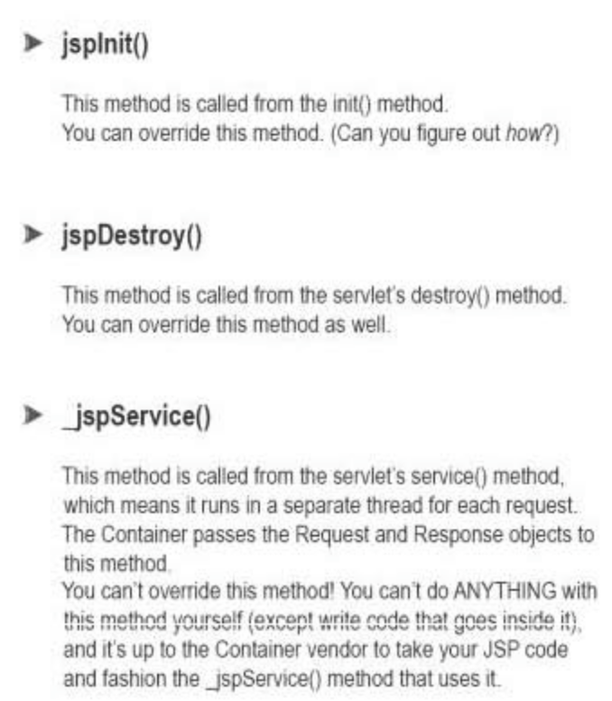

Initializing Your JSP
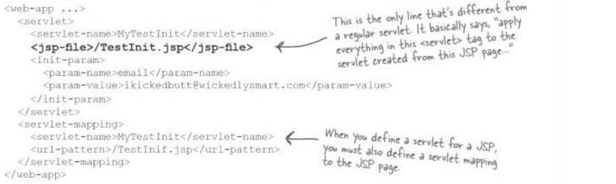

Attributes / Scope in JSP
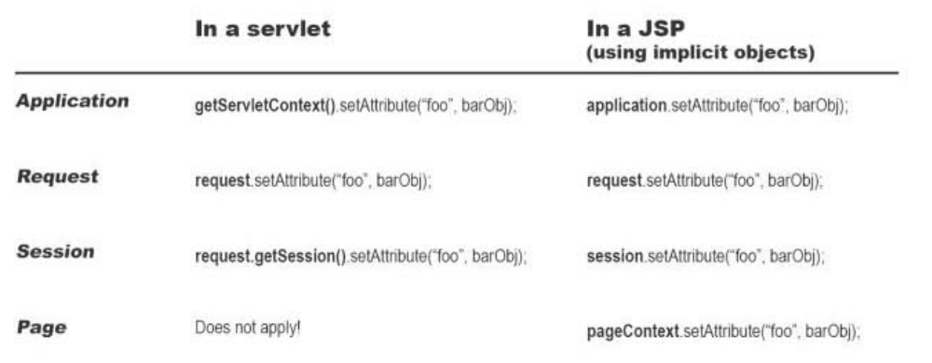

JSP Elements Types


Scriplet
Scriptlet used to embed Java code inside JSP: Adding dynamic content
JSP also allows you to write blocks of Java code inside the JSP. You do this by placing your Java code between <% and %> characters (just like expressions, but without the = sign at the start of the sequence.)
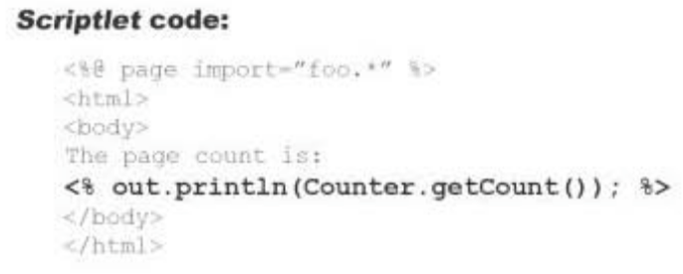
Example: scripletExample.jsp
Exercise: Write a JSP to output the entire line, "Hello! The time is now ..." but use a scriptlet for the complete string, including the HTML tags.

Expression
Expression used to work as out.println(): For adding dynamic content
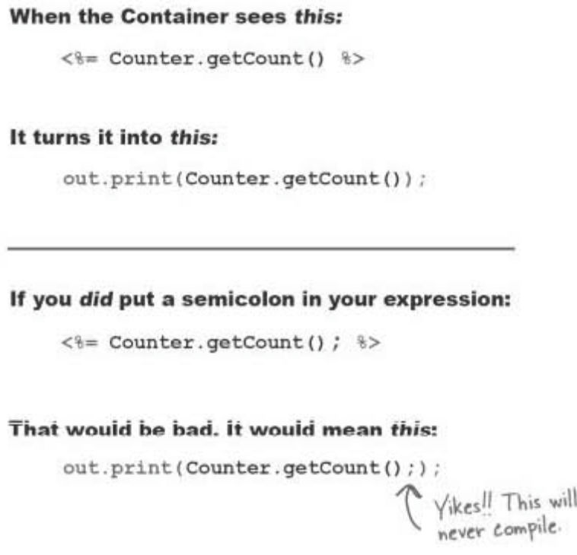
Example: expressionExample.jsp
Exercise: Write a JSP to output the values returned by System.getProperty for various system properties such as java.version, java.home, os.name, user.name, user.home, user.dir etc.

Directive
Directive is used to import any packages
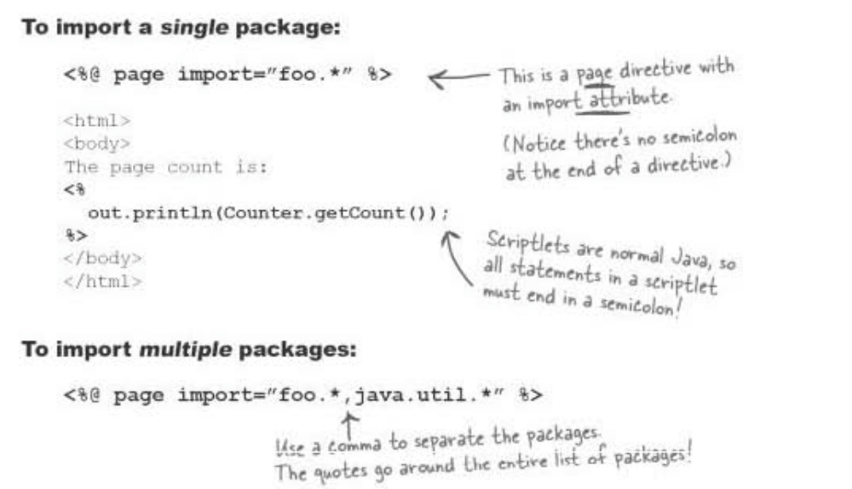
Declarative element are used to declare a variable or define a method inside JSP page
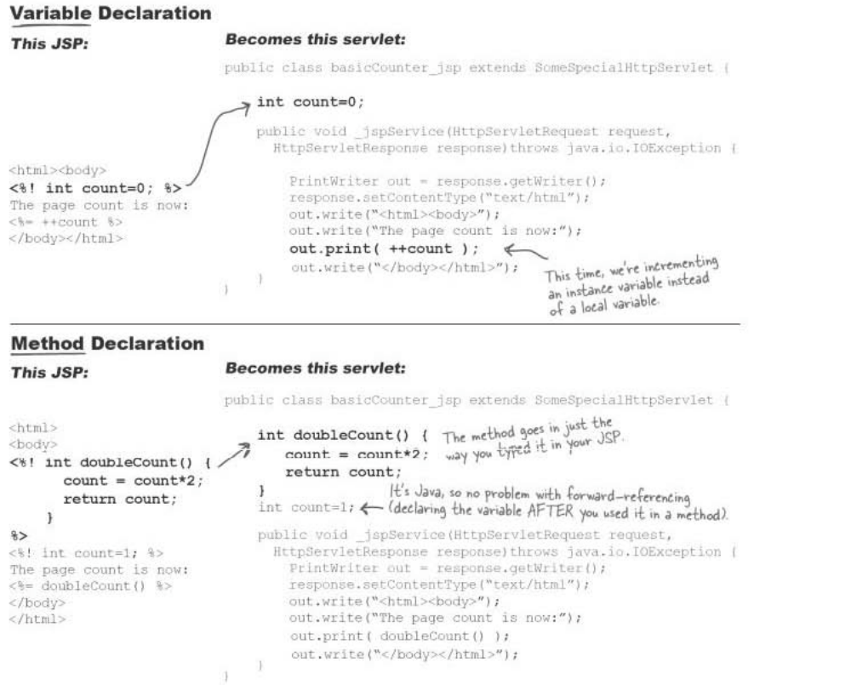
Example: declarationExample.jsp, methodDeclaration.jsp

Jsp / Servlet Code Mapping
- All declaratives code goes as instance level of class not inside service method
- All Scriplets / Expressions goes inside service method (_jspService())

Implicit Object of Jsp
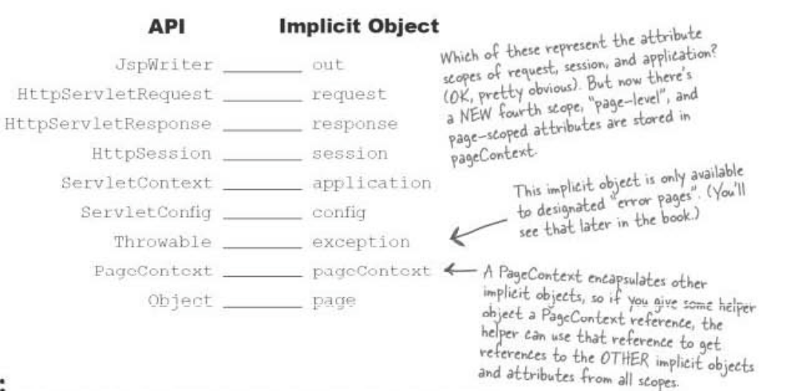
Example of JSP request implicit object: staticpage/SubmitUser.html, requestProcessor.jsp
Example of JSP response implicit object: http://www.javatpoint.com/response-implicit-object
Example of JSP out implicit object: http://www.javatpoint.com/jsp-implicit-objects
Question: Why we need JSPWriter instead of PrintWriter inside JSP?
JspWriter is a buffered version of the PrintWriter. JspWriter also differs from a PrintWriter by throwing java.io.IOException, which a PrintWriterdoes not. The advantage of throwing an exception is that if your HTTP connection is broken for some reason, your JSP won’t sit there trying to send characters to a broken connection.
The initial JspWriter object is associated with the PrintWriter object of the ServletResponse in a way that depends on whether the page is or is not buffered. If the page is not buffered, output written to this JspWriter object will be written through to the PrintWriter directly. But if the page is buffered, the PrintWriter object will not be created until the buffer is flushed and operations like setContentType() are legal. Since this flexibility simplifies programming substantially, buffering is the default for JSP pages.
Example of JSP config implicit object: http://www.javatpoint.com/config-implicit-object
Example of JSP application implicit object: http://www.javatpoint.com/application-implicit-object
Example of JSP session implicit object: http://www.javatpoint.com/application-implicit-object
Example of JSP page implicit object: http://www.javatpoint.com/application-implicit-object

Using pageContext
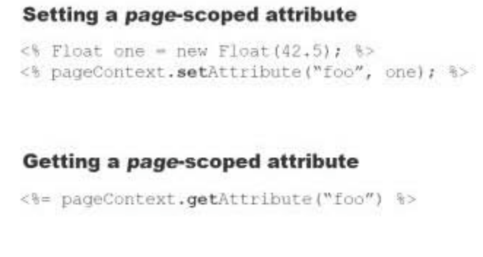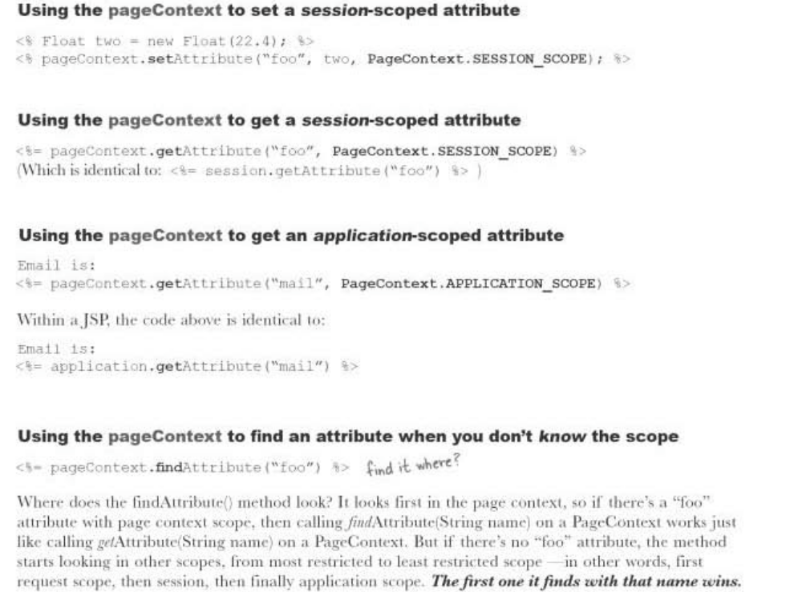
Example of JSP pageContext implicit object: http://www.javatpoint.com/pageContext-implicit-object

Exception Handling in JSP
The exception is normally an object that is thrown at runtime. Exception Handling is the process to handle the runtime errors. There may occur exception any time in your web application. So handling exceptions is a safer side for the web developer. In JSP, there are two ways to perform exception handling:
- By errorPage and isErrorPage attributes of page directive
- By <error-page> element in web.xml file
Example of JSP exception implicit object:
- Form which take input from User & after submission call a JSP page
staticpage/LoginForm.html
- Controller which validate Login – jsp/LoginValidator.jsp
- create a page to handle the exceptions - jsp/ErrorHandler.jsp
http://localhost:8080/GpsServletNewApplication/staticpage/LoginForm.html

Overriding jspInit()
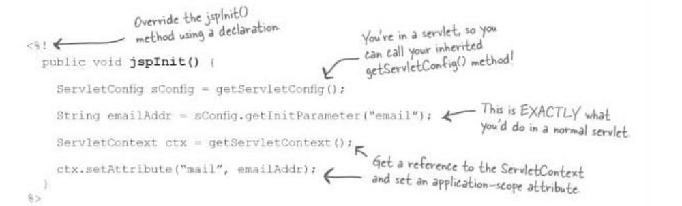
Question: Why we need to override _jspInit method?
Once a JSP file is successfully compiled into a class file, jsp engine calls jspInit() method to initialize class file. This method is called by the container only once during the lifecycle. jspInit() method can be overridden by the author to initialize resources such as database and network related connections.
Question: Why we shouldn’t use constructor instead of init method of jsp or servlet?
We won't have access to a ServletConfig or ServletContext if we use constructor instead of init() method.

A Comment…
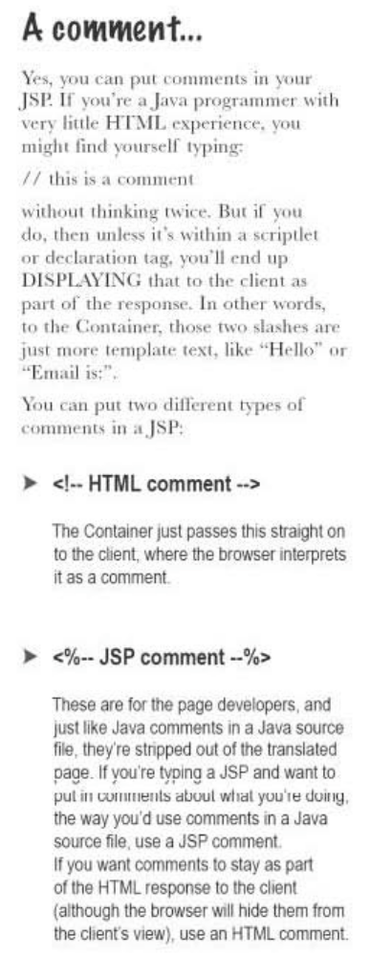

Types of Directives
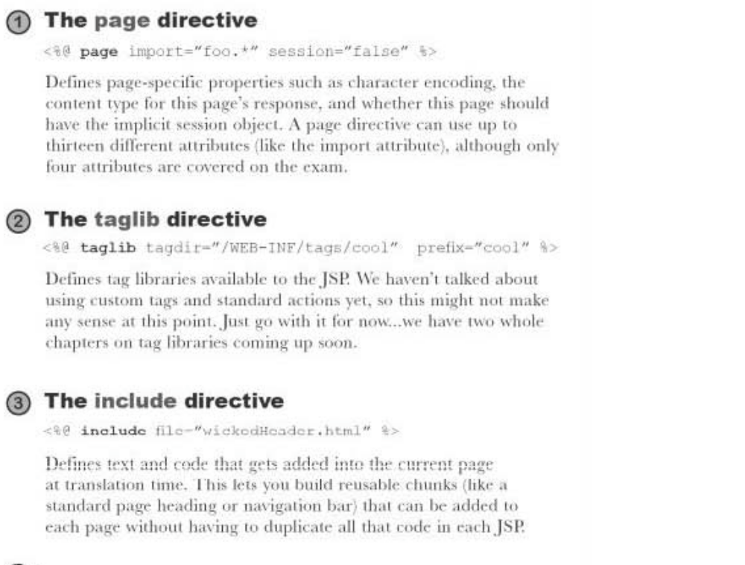

Few attributes of Page Directive
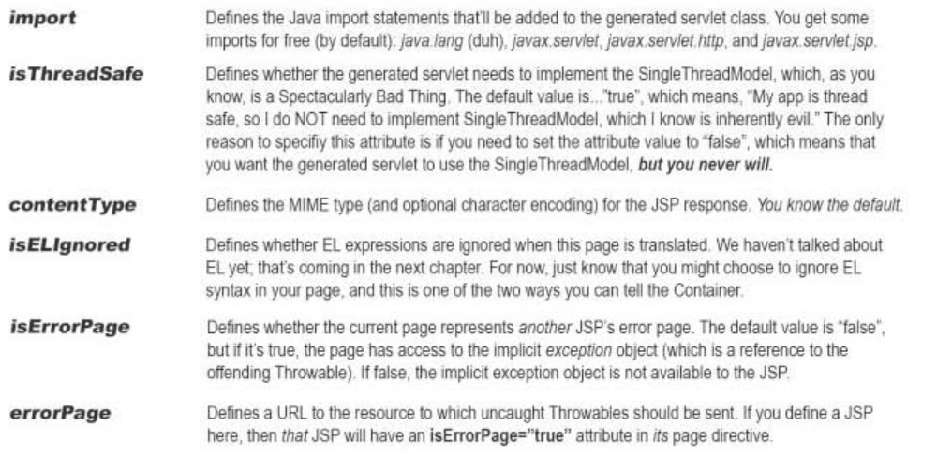

Standard Action elements

Jsp:useBean and jsp:getProperty
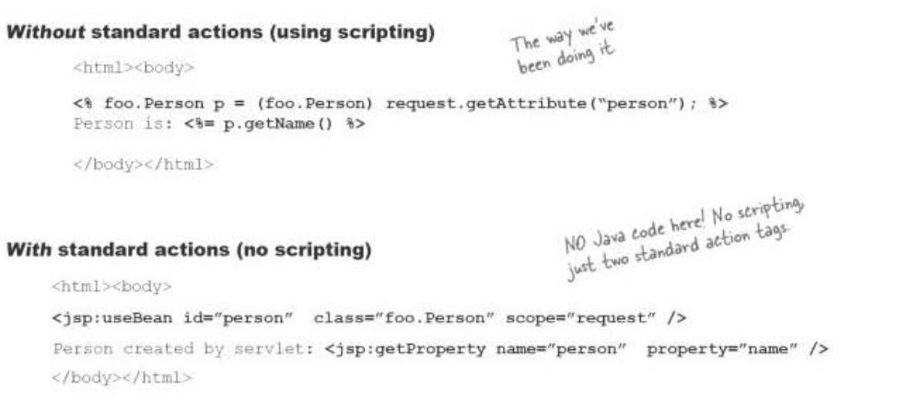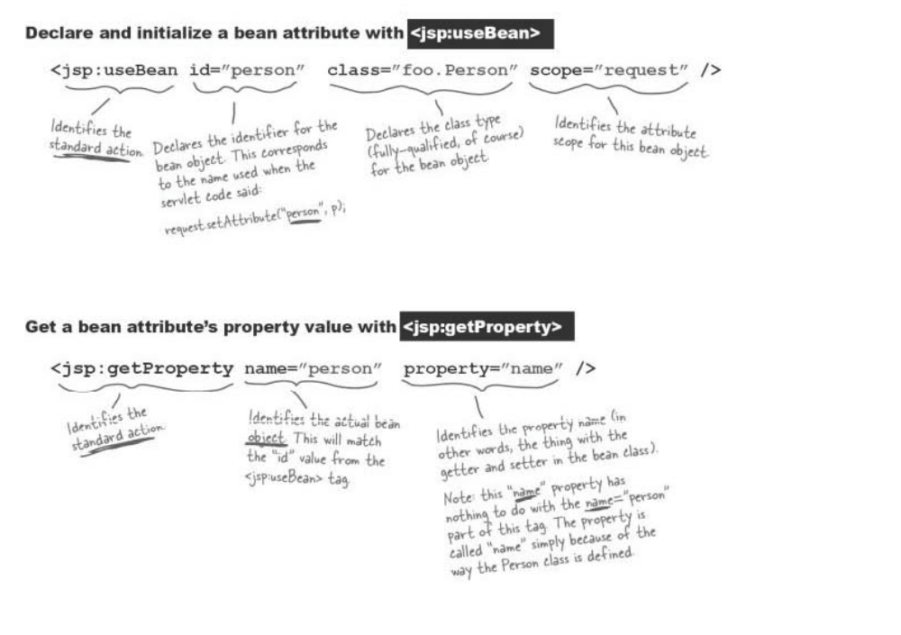


Jsp:setProperty
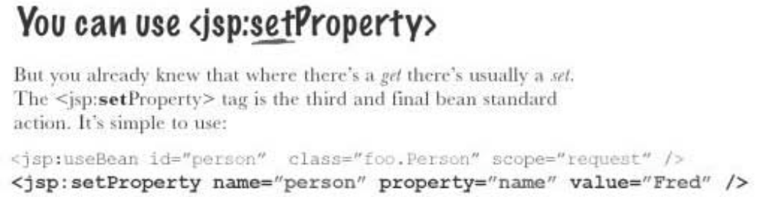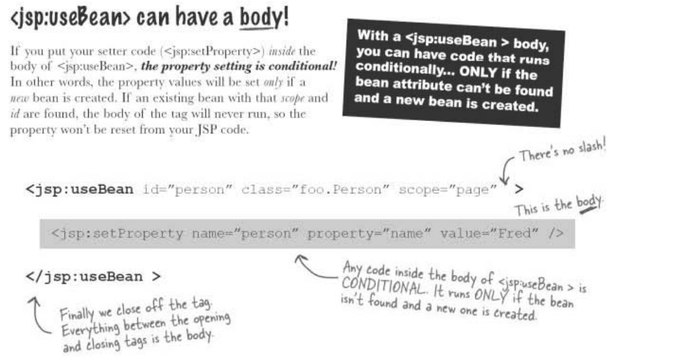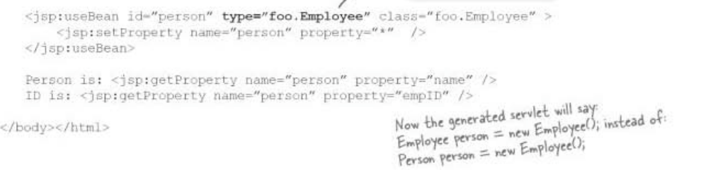

<jsp:include> Standard Action
Runtime - Includes a static file or the result from another web component.

JSP Syntax
<jsp:include page="{relativeURL | <%= expression %>}"
flush="true| false" />
or
<jsp:include page="{relativeURL | <%= expression %>}"
flush="true| false" >
<jsp:param name="parameterName"
value="{parameterValue | <%= expression %>}" />+
</jsp:include>

Examples
<jsp:include page="scripts/login.jsp" />
<jsp:include page="copyright.html" />
<jsp:include page="/index.html" />
<jsp:include page="scripts/login.jsp">
<jsp:param name="username" value="jsmith" />
</jsp:include>

Description
The <jsp:include> element allows you to include either a static or dynamic resource in a JSP page. The results of including static and dynamic resources are quite different. If the resource is static, its content is included in the calling JSP page. If the resource is dynamic, it acts on a request and sends back a result that is included in the JSP page. When the include action is finished, the JSP container continues processing the remainder of the JSP page.
You cannot always determine from a pathname if a resource is static or dynamic. For example, http://server:8080/index.html might map to a servlet through a server alias. The <jsp:include> element handles both types of resources, so it is convenient to use when you don't know whether the resource is static or dynamic.
If the included resource is dynamic, you can use a <jsp:param> clause to pass the name and value of a parameter to the resource. As an example, you could pass the string username and a user's name to a login form that is coded in a JSP page.

Attributes
- page="{ relativeURL | <%= expression %> }"
The relative URL that locates the resource to be included, or an expression that evaluates to a String equivalent to the relative URL.
The relative URL looks like a pathname--it cannot contain a protocol name, port number, or domain name. The URL can be absolute or relative to the current JSP page. If it is absolute (beginning with a /), the pathname is resolved by your web or application server.
- flush="true | false"
If the page output is buffered and the flush attribute is given a true value, the buffer is flushed prior to the inclusion, otherwise the buffer is not flushed. The default value for the flush attribute is false.
- <jsp:param name="parameterName"
value="{parameterValue | <%= expression %>}" />+

The <jsp:param> clause allows you to pass one or more name/value pairs as parameters to an included resource. The included resource should be dynamic, that is, a JSP page, servlet, or other resource that can process the parameter.
You can use more than one <jsp:param> clause if you want to send more than one parameter to the included resource. The name attribute specifies the parameter name and takes a case-sensitive literal string. The value attribute specifies the parameter value and takes either a case-sensitive literal string or an expression that is evaluated at request time.

<jsp:forward> Standard Action
Forwards a client request to an HTML file, JSP file, or servlet for processing.

JSP Syntax
<jsp:forward page={"relativeURL" | "<%= expression %>"} />
or
<jsp:forward page={"relativeURL" | "<%= expression %>"} >
<jsp:param name="parameterName"
value="{parameterValue | <%= expression %>}" />+
</jsp:forward>

Examples
<jsp:forward page="/servlet/login" />
<jsp:forward page="/servlet/login">
<jsp:param name="username" value="jsmith" />
</jsp:forward>

Description
The <jsp:forward> element forwards the request object containing the client request information from one JSP file to another file. The target file can be an HTML file, another JSP file, or a servlet, as long as it is in the same application context as the forwarding JSP file. The lines in the source JSP file after the <jsp:forward> element are not processed.
You can pass parameter names and values to the target file by using a <jsp:param> clause. An example of this would be passing the parameter name username (with name="username") and the value scott (with value="scott") to a servlet login file as part of the request. If you use <jsp:param>, the target file should be a dynamic file that can handle the parameters.
Be careful when using <jsp:forward> with unbuffered output. If you have used the <%@ page %> directive with buffer=none to specify that the output of your JSP file should not be buffered, and if the JSP file has any data in the out object, using <jsp:forward> will cause an IllegalStateException.

Attributes
- page="{relativeURL | <%= expression %>}"
A String or an expression representing the relative URL of the file to which you are forwarding the request. The file can be another JSP file, a servlet, or any other dynamic file that can handle a request object.
The relative URL looks like a path-it cannot contain a protocol name, port number, or domain name. The URL can be absolute or relative to the current JSP file. If it is absolute (beginning with a /), the path is resolved by your Web or application server.
- <jsp:param name="parameterName" value="{parameterValue | <%= expression %>}" />+
Sends one or more name/value pairs as parameters to a dynamic file. The target file should be dynamic, that is, a JSP file, servlet, or other file that can process the data that is sent to it as parameters.
You can use more than one <jsp:param> clause if you need to send more than one parameter to the target file. The name attribute specifies the parameter name and takes a case-sensitive literal string as a value. The value attribute specifies the parameter value and takes either a case-sensitive literal string or an expression that is evaluated at request time.

The Include directive
Translation time - Includes a static file in a JSP file, parsing the file's JSP elements.

Syntax
<%@ include file="relativeURL" %>

Examples
include.jsp:
<html>
<head><title>An Include Test</title></head>
<body bgcolor="white">
<font color="blue">
The current date and time are
<%@ include file="date.jsp" %>
</font>
</body>
</html>
date.jsp:
<%@ page import="java.util.*" %>
<%= (new java.util.Date() ).toLocaleString() %>
Displays in the page:
The current date and time are
Aug 30, 1999 2:38:40

Description
The <%@ include %> directive inserts a file of text or code in a JSP file at translation time, when the JSP file is compiled. When you use the <%@ include %> directive, the include process is static. A static include means that the text of the included file is added to the JSP file. The included file can be a JSP file, HTML file, or text file. If the included file is a JSP file, its JSP elements are translated and included (along with any other text) in the JSP file. Once the included file is translated and included, the translation process resumes with the next line of the including JSP file.
The included file can be an HTML file, a JSP file, a text file, or a code file written in the Java programming language. Be careful that the included file does not contain <html>, </html>, <body>, or </body> tags. Because the entire content of the included file is added to the including JSP file, these tags would conflict with the same tags in the including JSP file, causing an error.
Some of the behaviors of the <%@ include %> directive depend on the particular JSP container you are using, for example:
- The included file might be open and available to all requests, or it might have security restrictions.
- The JSP page might be recompiled if the included file changes.

Attributes
- file="relativeURL"
The pathname to the included file, which is always a relative URL. Simply put, a relative URL is just the path segment of an URL, without a protocol, port, or domain name, like this:
"error.jsp"
"/templates/onlinestore.html"
"/beans/calendar.jsp"
If the relative URL starts with /, the path is relative to the JSP application's context, which is a javax.servlet.ServletContext object that is in turn stored in the application object. If the relative URL starts with a directory or file name, the path is relative to the JSP file.
Question: When do we need to use include directive and include action?
- The purpose of using inclusion in JSP pages is to reduce code redundancy and to promote reusability. In many web applications, there are some common elements you need to display in many pages. For example, company logo, copy right information, and so on. Instead of reproducing those common pieces in each of JSP pages, you can factor that common code into other files and include them into JSP pages using inclusion mechanism provided by JSP engine. The application's maintainability (you just need to make changes in only one place) and reusability gets improved.
- <%@ include file=> statically inserts the file at the time the JSP page is translated into a servlet. Usually when you want to include static content, like page header and footer, you can use include directive.
- <jsp:include> dynamically inserts the file at the time the page is requested. Usually when you cannot determine whether the file is static or dynamic, you can use include action.
- If the included file is changed but not the JSP which is including it then the changes will reflect only when we use include action tag. The changes will not reflect if you are using include directive as the JSP is not changed so it will not be translated (during this phase only the file gets included when using directive) for request processing and hence the changes will not reflect.
- When using include action tag we can also pass the parameters to the included page by using param action tag but in case of include directive it’s not possible.

Custom Tag
A custom tag is a user-defined JSP language element. When a JSP page containing a custom tag is translated into a servlet, the tag is converted to operations on an object called a tag handler. The Web container then invokes those operations when the JSP page's servlet is executed.
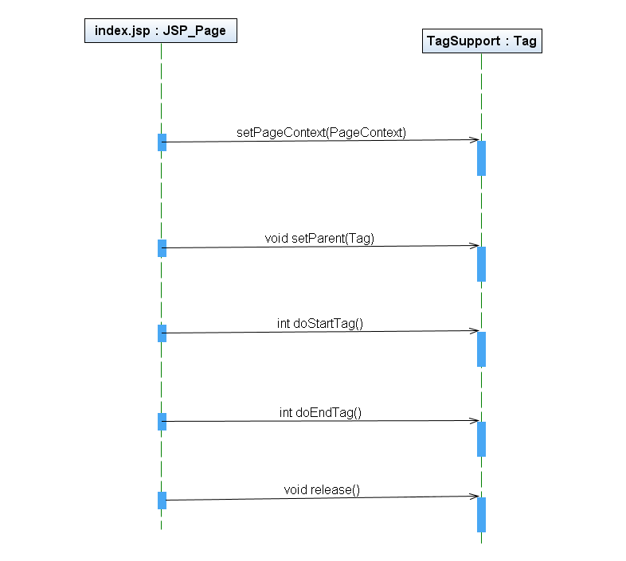
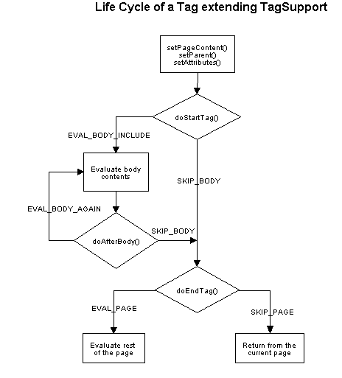

Why do we need Custom tag in JSP?
We can use JSP Action Elements, JSP EL and JSP Standard Tag Library to avoid scripting elements in JSP pages. But sometimes even these are not enough and we might get tempted to write java code to perform some operations in JSP page. Fortunately JSP is extendable and we can create our own custom tags to perform certain operations.
Let’s say we want to show a number with formatting with commas and spaces. This can be very useful for user when the number is really long. So we want some custom tags like below:
<mytags:formatNumber number="100050.574" format="#,###.00"/>
Based on the number and format passed, it should write the formatted number in JSP page, for above example it should print 100,050.57

Steps to create a custom tag

Understanding flow of custom tag in jsp
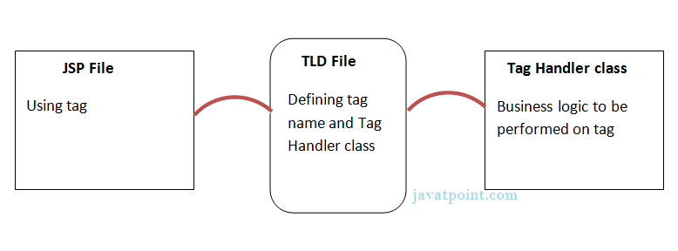

Create JSP Custom Tag Handler class
Implement one of three interfaces, SimpleTag, Tag, or BodyTag, which define methods that are invoked during the life cycle of the tag.
Implement the javax.servlet.jsp.tagext.SimpleTag interface if you wish to use a much simpler invocation protocol. The SimpleTag interface does not extend thejavax.servlet.jsp.tagext.Tag interface as does the BodyTag interface. Therefore, instead of supporting the doStartTag() and doEndTag() methods, the SimpleTag interface provides a simple doTag() method, which is called once and only once for each tag invocation.
This is the first step in creating custom tags in JSP. All we need to do is extendjavax.servlet.jsp.tagext.SimpleTagSupport class and override doTag() method. The important point to note is that we should have setter methods for the attributes we need for the tag. So we will define two setter methods – setFormat(String format) and setNumber(String number).
SimpleTagSupport provide methods through which we can get JspWriter object and write data to the response. We will use DecimalFormat class to generate the formatted string and then write it to response.
Example - com.gps.custom.NumberFormatterTag.java

Creating Tag Library Descriptor (TLD) File
Once the tag handler class is ready, we need to define a TLD file inside the WEB-INF directory so that container will load it when application is deployed.
Example – WEB-INF\tld\numberformatter.tld

Deployment Descriptor Configuration
We will include the tag library in web application using jsp-config and taglib.
Example – WEB-INF\web.xml

JSP Page using Custom Tag
Example – jsp\DisplayFormattedNumber.jsp
http://localhost:8080/GpsServletNewApplication/DisplayNumber

JSP Custom Tag with attribute with database
Scenario- Let's create a custom tag that prints a particular record of table for the given table name and id.
PrintRecord.java, printRecord.tld, DisplayData.jsp, web.xml
http://localhost:8080/GpsServletNewApplication/DisplayData

JSP Custom Tag with Body content & attribute
ChangeCaseTag.java, changeCase.tld, ChangeCase.jsp, web.xml
http://localhost:8080/GpsServletNewApplication/ChangeCase

When do we need to create JAR file for tlds?
If you have a lot of custom tag handler classes or you want it to provide as a JAR file for others to use, you need to include TLD files in the META-INF directory of the JAR file and include it in the web application lib directory. In that case, we don’t need to configure them in web.xml also because JSP container takes care of that. That’s why when we use JSP Standard Tags, we don’t need to configure them in web.xml and we can declare them in JSP and use them.
More references
http://www.javatpoint.com/custom-tags

How to Invalidate Scriplet
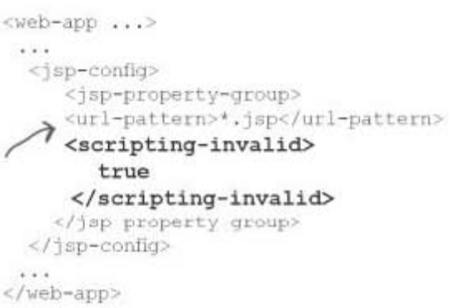
By default scripting-invalid is false.

How to enable / disable Expression Language (EL)
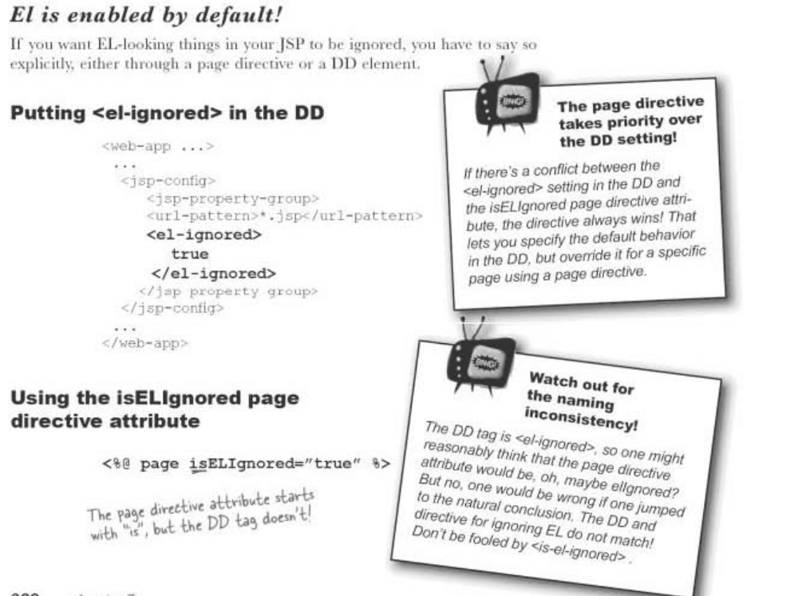

Basic of Expression Language (EL)
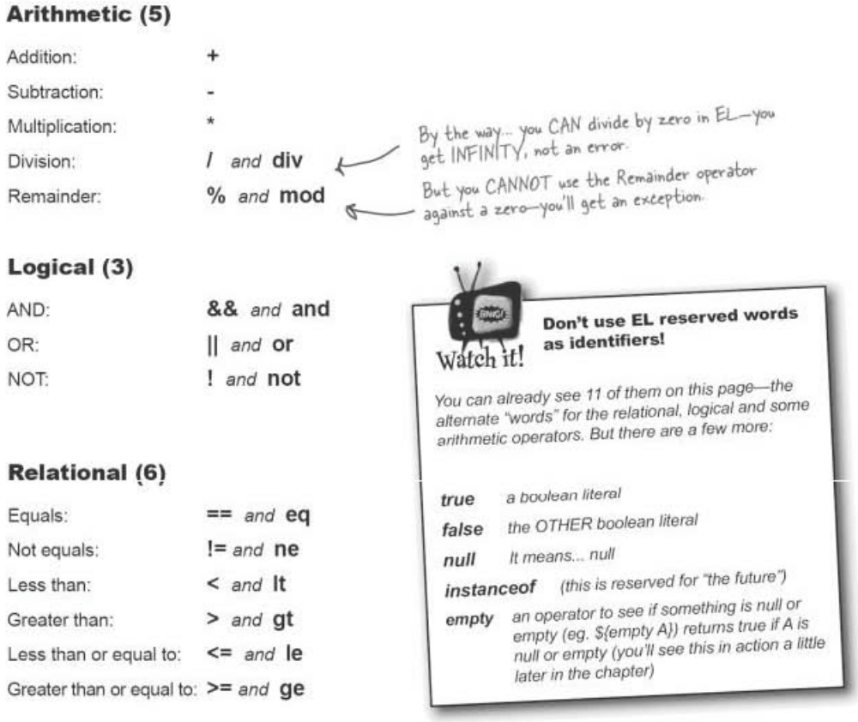

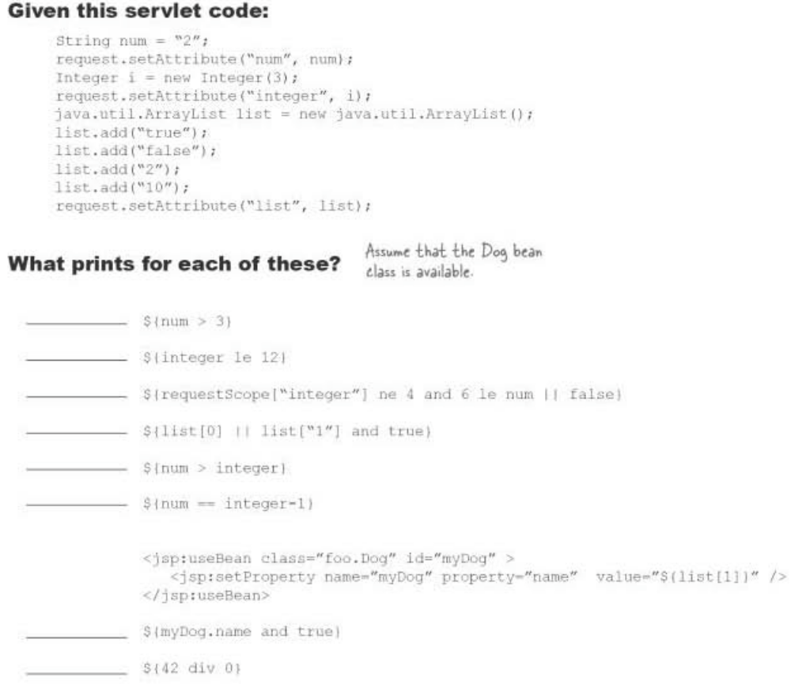
Ans:
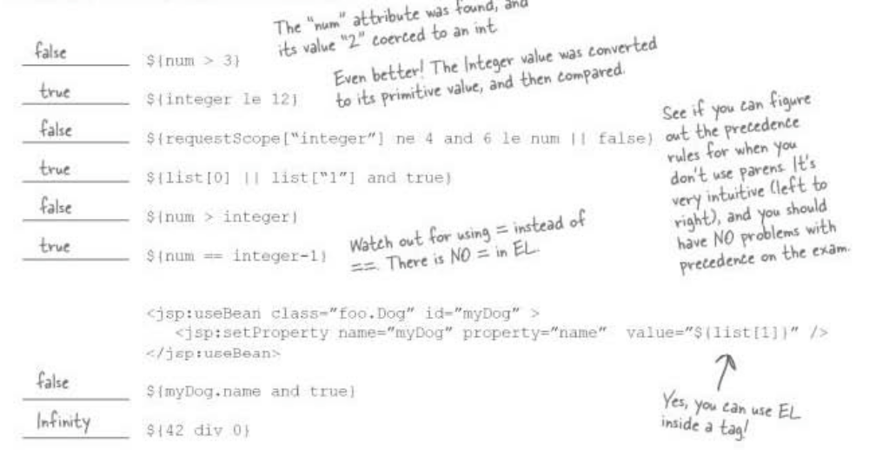

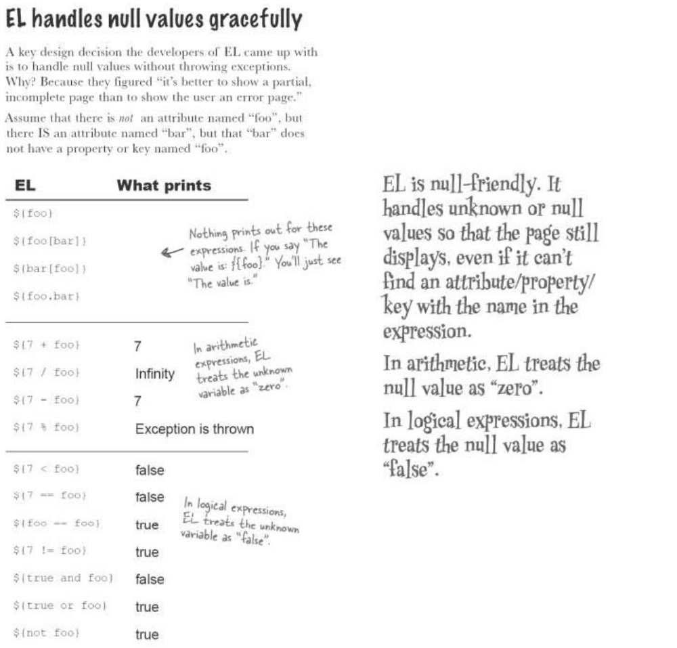

Few JSTL Syntax
Before you can use JSTL, you need to put two files, “jstl.jar” and “standard.jar” into the WEB-INF/lib directory of your web app.

<c:out>
It provides a default attribute
<b>Hello <c:out value=’${user}’ default=’guest’ />.</b>

Example1:
<table>
<% String[] items = (String[]) request.getAttribute(“movieList”);
String var=null;
for (int i = 0; i < items.length; i++) {
var = items[i];
%>
<tr><td><%= var %></td></tr>
<% } %>
</table>

<c:forEach>
The <c:forEach> tag from the JSTL is perfect for this—it gives you a simple way to iterate over arrays and collections.
<%@ taglib prefix=”c” uri=”http://java.sun.com/jsp/jstl/core” %>
<html><body>
<strong> Movie list:</strong>
<br><br>
<table>
<c:forEach var=”movie” items=”${movieList}” >
<tr>
<td>${movie}</td>
</tr>
</c:forEach>
</table>
</body></html>
Example2:
Servlet code:
String[] movies1 = {“Matrix Revolutions”, “Kill Bill”, “Boondock Saints”};
String[] movies2 = {“Amelie”, “Return of the King”, “Mean Girls”};
java.util.List movieList = new java.util.ArrayList();
movieList.add(movies1);
movieList.add(movies2);
request.setAttribute(“movies”, movieList);

JSP page-
<table>
<c:forEach var=”listElement” items=”${movies}” >
<c:forEach var=”movie” items=”${listElement}” >
<tr>
<td>${movie}</td>
</tr>
</c:forEach>
</c:forEach>
</table>

<c:if>
Example3:
<c:if test=”${userType eq ‘member’ }” >
<jsp:include page=”inputComments.jsp”/>
</c:if>
Example4:
<% String pref = (String) session.getAttribute(“userPref”);
if (pref.equals(“performance”)) {
out.println(“Now you can stop even if you <em>do</em> drive insanely fast.”);
} else if (pref.equals(“safety”)) {
out.println(“Our brakes won’t lock up, no matter how bad a driver you are. “);
} else if (pref.equals(“maintenance”)) {
out.println(“ Lost your tech job? No problem--you won’t have to service these brakes for at least three years.”);
} else {
out.println(“Our brakes are the best.”);
} %>
<c:if test=”${userPref==’performance’}” >
Now you can stop even if you <em>do</em> drive insanely fast..
</c:if>
<c:if test=”${userPref==’safety’}” >
Our brakes won’t lock up no matter how bad a driver you are.
</c:if>
<c:if test=”${userPref==’maintenance’}” >
Lost your tech job? No problem--you won’t have to service these brakes for at least three years.
</c:if>
OR
<c:choose>
<c:when test=”${userPref == ‘performance’}”>
Now you can stop even if you <em>do</em> drive insanely fast.
</c:when>
<c:when test=”${userPref == ‘safety’}”>
Our brakes will never lock up, no matter how bad a driver you are.
</c:when>
<c:when test=”${userPref == ‘maintenance’}”>
Lost your tech job? No problem--you won’t have to service these brakes for at least three years.
</c:when>
<c:otherwise>
Our brakes are the best.
</c:otherwise>
</c:choose>
Example5:
<c:set var=”userLevel” scope=”session” value=”Cowboy” />
<c:set var=”Fido” value=”${person.dog}” />
<c:import url=”http://www.wickedlysmart.com/skyler/horse.html” />
Dynamic: adds the content from the value of the URL attribute to the current page, at request time. It works a lot like <jsp:include>, but it’s more powerful and flexible.
<c:import url=”Header.jsp” >
<c:param name=”subTitle” value=”We take the sting out of SOAP.” />
</c:import>

Syntax & Examples
http://www.javatpoint.com/jstl
http://www.journaldev.com/2090/jstl-tutorial-with-examples-jstl-core-tags

Configuring Error page in DD
Declarative Error handling:
<error-page>
<exception-type>java.lang.Throwable</exception-type>
<location>/errorPage.jsp</location>
</error-page>
<error-page>
<error-code>404</error-code>
<location>/notFoundError.jsp</location>
</error-page>
A more explicit ERROR page (“errorPage.jsp”)
<%@ page isErrorPage=”true” %>
<html><body>
<strong>Bummer.</strong><br>
You caused a ${pageContext.exception} on the server.<br>
<img src=”images/bummerGuy.jpg”>
</body></html>

Auto Page Refresh
Consider a webpage which is displaying live game score or stock market status or currency exchange ration. For all such type of pages, you would need to refresh your web page regularly using refresh or reload button with your browser.
JSP makes this job easy by providing you a mechanism where you can make a webpage in such a way that it would refresh automatically after a given interval.
The simplest way of refreshing a web page is using method setIntHeader() of response object. Following is the signature of this method:
public void setIntHeader(String header, int headerValue)
This method sends back header "Refresh" to the browser along with an integer value which indicates time interval in seconds.
Example- jsp\AutoRefresh.jsp http://localhost:8080/GpsServletNewApplication/Refresh

